**Performance test for DocumentCategory**

**Test Summary:**

|  |  |
| --- | --- |
| Kernel Request | DocumentCategory |
| Base URL | https://integ.mosip.io |
| Execution Window | 2019/01/07 04:01 PM IST to 2019/01/07 04:31 PM IST |
| Maximum User Load | 100 |
| Tool Used | Jmeter |
| Average Response Time | 1711 |
| Throughput Achieved | 25.50 |

**Transaction Summary:**

|  |  |  |  |  |  |  |  |
| --- | --- | --- | --- | --- | --- | --- | --- |
| Label | #Sample | Average | 90% line(ms) | Min(ms) | Max(ms) | Error% | Throughput/Sec |
| Service to create document category | 11469 | 1820 | 3243 | 78 | 42311 | 0.19% | 5.12 |
| GetAllDocumentCategory | 11450 | 1784 | 3268 | 67 | 42098 | 0.29% | 5.13 |
| Service to update document category | 11430 | 1800 | 3230 | 70 | 42215 | 0.42% | 5.11 |
| GetDocumentCategoryByCodeAndLangCode | 11409 | 1554 | 3171 | 63 | 42236 | 0.41% | 5.13 |
| GetAllDocumentCategoryByLaguageCode | 11391 | 1598 | 3172 | 79 | 42186 | 0.21% | 5.12 |

Bytes Throughput Over Time (bytes/sec) (bytes/sec)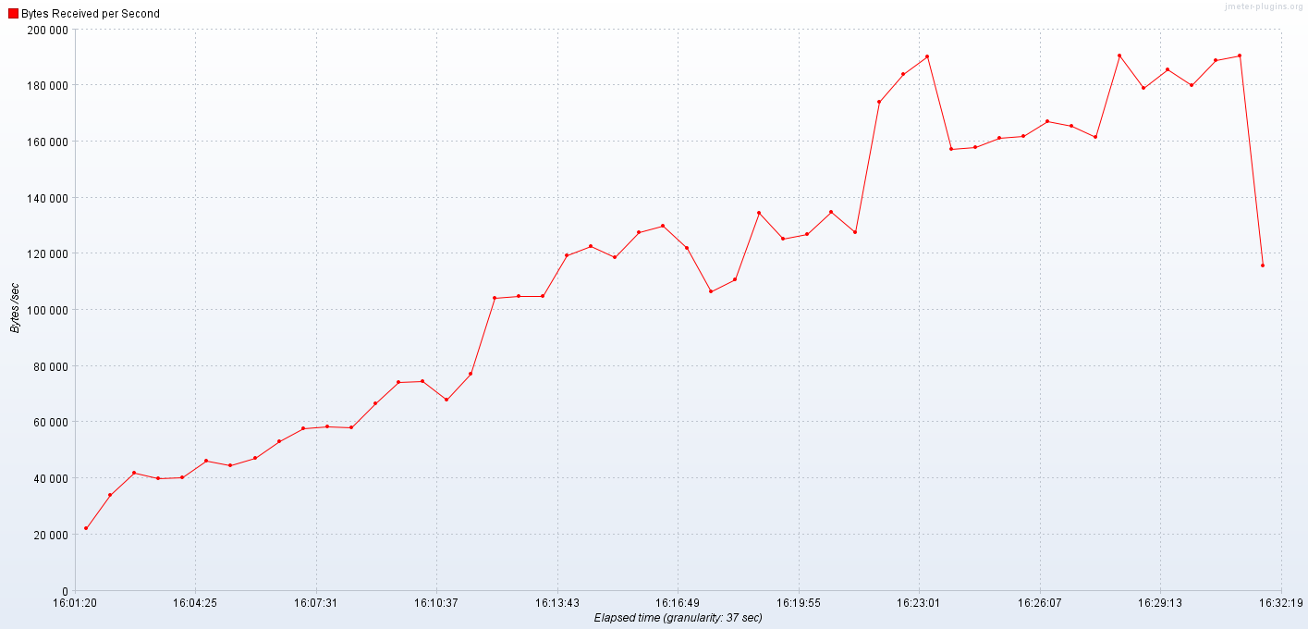

Response Times Over Time

